Very good!

In 1c) you would need first to find relative wind velocity:
uw = Vw * cos(betaVw − x(6));
vw = Vw * sin(betaVw − x(6));
u_rw = x(1) − uw;
v_rw = x(2) − vw;
V_rw = sqrt(u_rw^2 + v_rw^2);
gamma_rw = −atan2(v_rw,u_rw);

Ywind = 0.5 * rho_a * V_rw^2 * cy*sin(gamma_rw) * A_Lw;
Nwind = 0.5 * rho_a * V_rw^2 * cn*sin(2*gamma_rw) * A_Lw*L;

In 2a) the linearized C_A and C_RB are wrong. From previous part you should have:
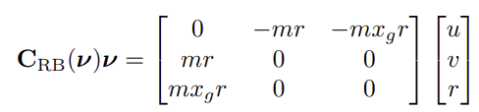
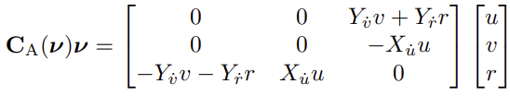
and after linearization you should have
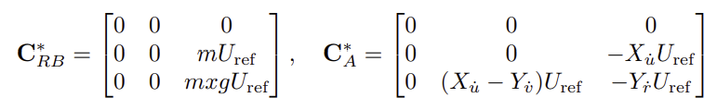
this should give the following transfer function
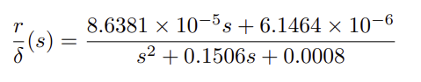
and you should get K = 0.0075 and T = 169.5493
For PID heading you could use Alg. 15.1 with Nomoto constants.

In 3e) the reason the actual speed of the marine craft fails to meet the exact desired speed is mainly that the expression for Td is based on a linear forward speed model, while the real model is highly nonlinear -> these unaccounted nonlinear effects will impact the surge velocity of the vessel and manifest themselves as a steady-state error between the true (nonlinear) and desired (linear) speeds.

